Katherine Barbarite of Whispering Hooves®
“Partnership & Confidence Building Horsemanship”

Presents
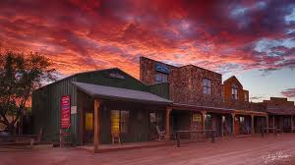
“Wild West Outpost” Riding Workshop
At
Tombstone Monument Ranch

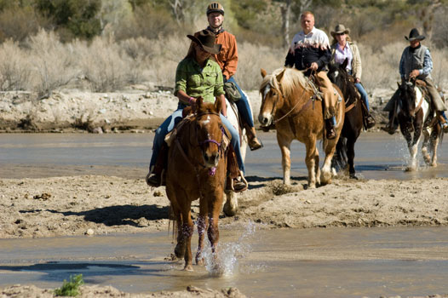
February 21-28, 2021

ENJOY Breath-taking views of the surrounding mountains, 272 acres of unspoiled land at this guest ranch fashioned as an Old Western town from the year 1881.
You are invited to experience a week long intensive program to hone your Horsemanship and Riding skills. It’s now time to explore the area on top of a horse, sit at the campfire, and listen to live music, or take a walk to the monument of Tombstone's founder Ed Schieffelin. Stay where cowboys and Indians used to fight, feel the spirit of the Apaches, breathe the air of the Wild West. Enjoy an all-inclusive educational vacation that features accommodation, all meals, riding activities, Horsemanship and Riding workshop and ranch entertainment.
The Ranch is located two miles Northwest of Tombstone, the legendary Wild West town where the famous gunfights between Wyatt Earp, Doc Holliday, the Clantons and McLaurys took place. In the vastness of the desert, where the Apaches once fought against the “Palefaces”, the spirit of the Native Americans is still palpable.

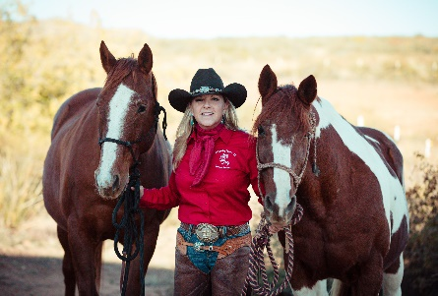
Your instructor in “Partnership & Confidence Building Horsemanship”, Katherine Barbarite, will be teaching a straight forward set of exercises that aids in the development of a calm confident horse and rider. No matter the skill level or discipline, these steps remove fear and resistance, elevating trust, communication and bond. Understand the importance herd structure and leadership to enhance safety and promote growth. Learn why bad timing and poor releases lead to unhappy horses.
“Ask… Wait… then Give for Results”
“Connect with the mind and the feet will follow” -------Katherine Barbarite
Certified Horse Trainer / Certified Horsemanship Association
Riding Instructor (Western & English)

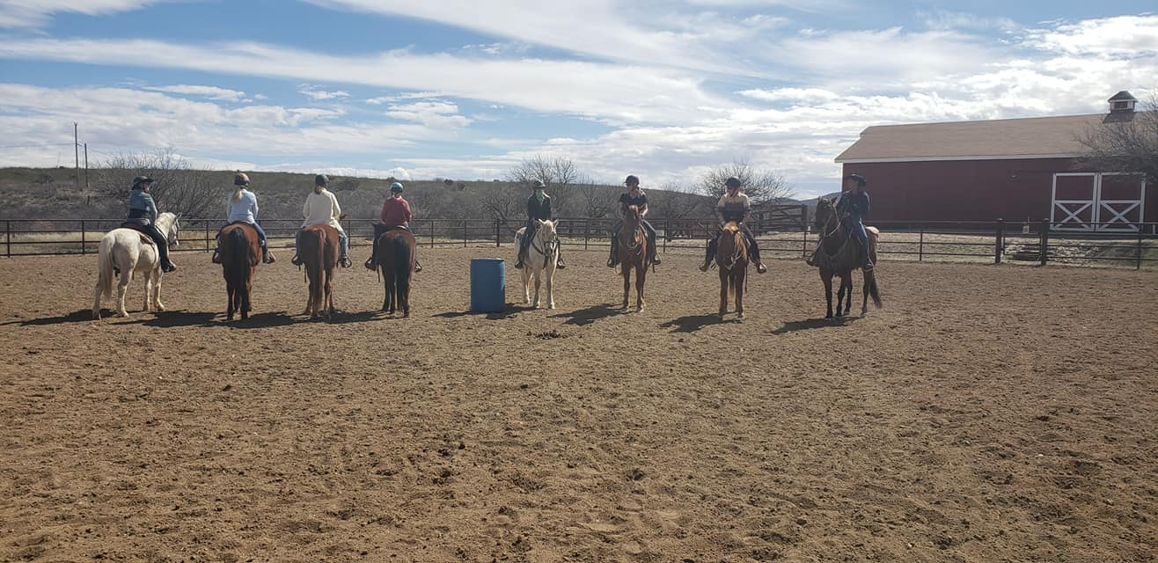
Topics:
Partner up with your horse and start building confidence and riding skills. Confront and overcome anxiety and fear that is caused by the unknown, increasing your confidence by understanding the mechanics of the four legs underneath you. Understand the “why, how and when” of communication when on the ground and in the saddle. This will gracefully improve your timing, finesse, balance and feel. Most of all,” become more than a passenger become a partner”.
Introduction: Leadership: Horse and Human Communication through Feel Technique: Difficult Saddling and Proper Fitting: Balance Horse and Rider w/Core Influence: Spooking and Shying: Aggressiveness and Nervousness: Jigging and Prancing: Mounting problems: Pullback :Bit acceptance: Proper Foot Handling: Ears& Head Shy : Clipping : Spraying : Bathing: Proper leading and Driving: Trailer Loading: Locating and Treating Pain: Mustang Gentling: Nutrition: Dentistry: Imprinting: Massage: Bits: Farrier: Flexion: soft and balanced movement: Understanding positions of open and closed doors: opposite diagonals: turn of the forehand: turn on the haunches : Black and White meaning: One Rein Stop: Safety Checking: Understand the 4x4 Method.

CLINIC DETAILS
Week long workshops are designed for those wanting to improve their confidence, communication, partnership and safe riding skills with horses. Professionals as well as pleasure riders benefit greatly from this week of intense study and fun. As the week progresses each day builds on the previous. Each day takes on its own personality as side trips riding into the rolling mountains and numerous multi colored canyon, discovering and learning about the fern and fauna, swimming, shooting authentic 1800’s era guns and adult camaraderie develop. Chuckwagon campfires, NEW Wine tasting, music, storytelling, dancing at the NEW barn dance, trying your hand in western poker like Wyatt Earp and recapping the day’s events with new friends at happy hour, is enjoyed by all. Viewed as an adult camp with a theme, this format has the highest retention by the students. Working with a large variety of horses with varying personalities and issues, is an invaluable opportunity and critical to the learning process. There is no substitute for handling dozens of horses this week.

Date: Sunday February 21, 2021 thru Sunday February 28, 2021

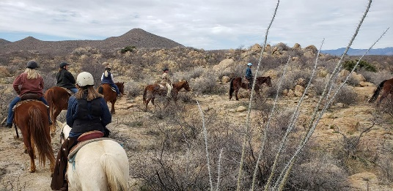
Location: Tombstone Monument Ranch
www.tombstonemonumentranch
info@tombstonemonumentranch.com
895 W. Monument Rd,
Tombstone, AZ 85638
520-457-7299 Attn: Michelle DE Splinter

Cost: SPECIAL Inclusive Pricing

Single Occupancy-----$2641 per person
Double Occupancy----$2326 per person

** $500 deposit is required to reserve your spot per person
**6.1% tax and 15% service charge not included

**Any dietary restrictions, please let the ranch know prior to arrival
*Limited Space Available*

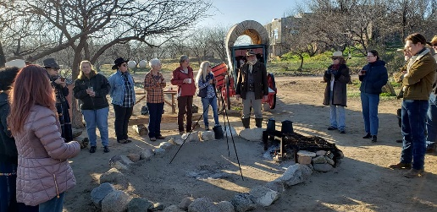
Details: Wonderful Accommodations, Horses and Tack, All Homemade Meals, Use of Ranch Facilities, Horseback Riding, Hiking, Outdoor Games, Swimming, Hot Tub, shooting 1800 period guns (extra), NEW “Two Step” Barn Dance, Bird Watching, NEW Wine Tasting, Horsemanship & Riding Workshop, Instructional Trails, and a whole lot more.

Testimonials: _____________________________________________

“She speaks of and about the Horses from her heart and mind always keeping the relationship foremost. Katherine is a true advocate of the Horse.”
Tara Reynolds, Twin Birch Farm

“Her program isn’t about getting caught up in labels, like ‘natural’, it’s about getting caught up in Horsemanship. I now understand herd mentality, ground work, patience, safety and so much more.”
Mike Talbot, Lost Acres Ranch

“No bells, whistles, special equipment, favorite breed, level or discipline. Communication, method and instruction to keep the horses and rider become better partners.”
Jodi Summerit Durango, CO

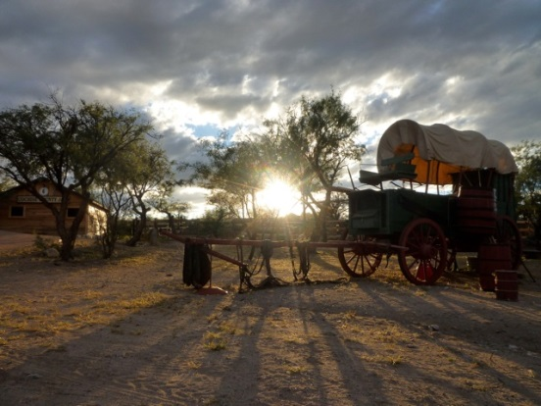
Contact:
Whispering Hooves
Katherine Barbarite
Author of the book: Whispering Hooves The Missing Art of Horsemanship
www.whisperinghooves.com
kathy@whisperinghooves.com
631-764-7515

See us on:

.

